Riadh Besbes  Education Counsellor  at the General Secretariat of the Supreme Council for Planning and Development in Kuwait  P.O. Box 15, Safat, P.C. 13001  Kuwait City, Kuwait  e-Mail:, Riadh.Besbes@gmail.com  Phone: (+965) 65790508 Kuwait  (+216) 22927343 Tunisia | 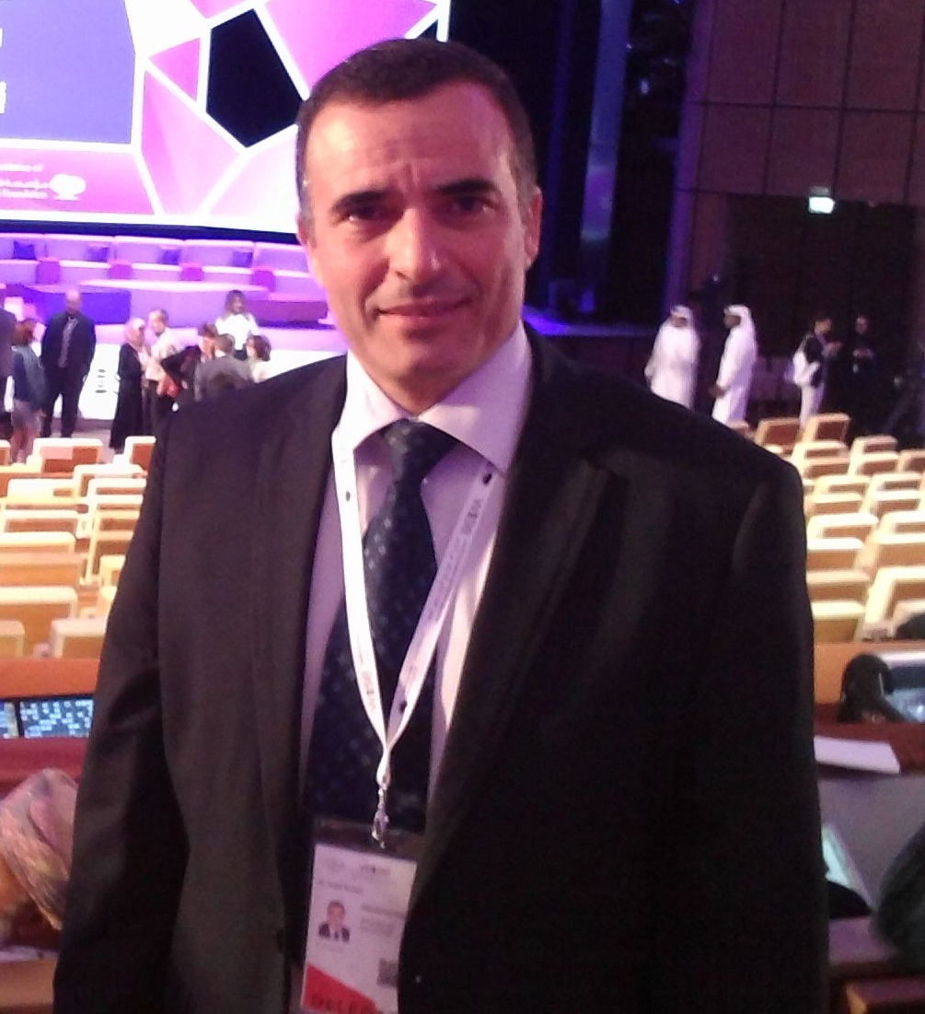

Personal Information
Nationality: Tunisian

Qualifications
- PhD “Information Systems Engineering”: National Engineering Institute of Sfax (ENIS), University of Sfax, Tunisia, May 2012
- Master of Ergonomics: Faculty of Medicine, Monastir, Tunisia, June 2010.
- Master of Electronics and instruments: Faculty of Sciences, Monastir, Tunisia, July 2002.
- Bachelor of Physics: Faculty of Sciences, Monastir, Tunisia, July 1989.

Experience
Education Counsellor
The General Secretariat of the Supreme Council for Planning and Development (SCPD) in State of Kuwait, Apr. 2016–Present:

- Writing research studies within SCPD development plans for the government of Kuwait on educational policies and strategies that contribute to provide enhancement to education sector;
- writing educational reports about educational outcomes from the public and private sectors, locally, nationally and internationally, including collaborative and interdisciplinary research, in areas related to the sustainable development goals;
- where applicable, developing mutually beneficial linkages with educational institutes in order to develop partnerships and collaborative research;
- transferring knowledge to society through outreach (e.g. collaborative research; seminars; workshops; lectures; websites; publications);
- Assist in the preparation of annual and strategic economic development plans;
- Prepare reports on the needs of the SCPD’s Committees with regard to research and propose the appropriate measures to address those needs;
- To produce and follow up various instructional materials to serve the development plans of the education sector

Inspector
- Ministry of education, Tunisia, Sep. 2007– Apr. 2016:
Missions:
- Teachers’ evaluation;
- Teachers’ training for scientific and educational professional development,
- Educational innovation

Physics Volunteer Assistant Professor
- Department of Physics, Preparatory Institute for Engineering Studies Monastir, Tunisia, (IPEIM), Sep. 2011 – Jun.2013:
Courses taught:
- Mechanics,
- Electrostatics,
- Optics,

Long Training Session
Inspector
- National Centre of Training the trainers in Education (CENAFFE) Carthage, Tunisia, Sep. 2005 – Aug.2007:
Alternatively, following theoretical courses for inspection’s professional development and practicing teachers’ assessment within schools.
Courses taught:
- Educational science,
- Professional development engineering,
- Sociology,
- Teaching assessment,
- Learning assessment,
- Pedagogy,
- Statistics

Training Workshop Attended
- Teacher In-Service Program (TISP), Institute of Electrical and Electronics Engineers (IEEE) held in Dubai, UAE, - Jun.13-14, 2014
- Teacher In-Service Program (TISP), Institute of Electrical and Electronics Engineers (IEEE) held in Tampa, Florida USA, - May.19-20, 2012
- Teacher In-Service Program (TISP), Institute of Electrical and Electronics Engineers (IEEE) held in Lusaka, Zambia, - Sep.24, 2010

Professional Affiliations
- IEEE member, Sep. 2010
- IEEE Pre-University Works (PUW) Committee, Coordinator for North Africa Region,-2012 and 2013.

Volunteer Experiences
- Participation in a series of online training under the auspices of IEEE, IEEE Pre-University Works Webinar , -Apr, 2012
- Teacher In-Service Program; Intercultural communication Webinar, -Apr. 2012
- EPICS-in-IEEE Global Webinar, -May 2012.

Language Skills
- Bilingual Arabic and French
- Competent in English

Research Interest
- Educational policies
- Educational instructions
- Teaching effectiveness evaluation.
- Learning performance assessment.
- Hierarchical fuzzy logic for Educational assessment.

Publications list
Theses:
- R. Besbes, “Hierarchical fuzzy system for Teaching effectiveness assessment,” Doctorate of Computerized systems Engineering thesis, May. 2012, Dept. of Electrical engineering, National Engineering School of Sfax (ENIS), University of Sfax, Tunisia, Tunisia.
- R. Besbes, “Cognitive Ergonomics: Teaching effectiveness Assessment,” Masters of Medicine, Jun. 2010, Univerity of Monastir, Tunisia.
- R. Besbes, “Simulation platform in physics,” Masters of electronics and instruments, July. 2002, Faculty of sciences, Univerity of Monastir, Tunisia.
Book chapters:
- R. Besbes (2016), Teaching and Learning Effectiveness Enhancement Project (TLEEP), pp. 53-70, ICT in Education in Global Context, the best practices in K-12 schools. Springer edition, ISSN 2196-4963, ISBN 978-981-10-0372-1, DOI 10.1007/978-981-10-0373-8.
- R. Besbes (2016), Learning Effectiveness Enhancement Project (LEEP), pp. 71-82, ICT in Education in Global Context, the best practices in K-12 schools. Springer edition, ISSN 2196-4963, ISBN 978-981-10-0372-1, DOI 10.1007/978-981-10-0373-8.
- R. Besbes (2016), Teaching Effectiveness Enhancement Project (TEEP), pp. 83-106, ICT in Education in Global Context, the best practices in K-12 schools. Springer edition, ISSN 2196-4963, ISBN 978-981-10-0372-1, DOI 10.1007/978-981-10-0373-8.
- R. Besbes (2015), للتشخيص الدّقيق والتقييم الناجع في الوسط الدِّراسي آليات استخراج البيانات. Arabic Journal of Information and Communication Technologies edited by Arab league educational, cultural and scientific organization (ALECSO).
- Besbes, R., Ghram, R., Khelifa, M.M., & Gorce Ph. (2012). Deuxième partie, chapitre 5 : enjeux d’usage, d’acceptation et d’appropriation de technologies dans les pratiques professionnelles. Vacherand-Revel, J., Dubois, M. , Bobillier Chaumon, M.E., Kouabenan, R. & Sarnin P. (2014). Changements organisationnels et technologiques : nouvelles pratiques de travail et innovations managériales. Paris : L’Harmattan.
- Besbes, R., Kabil, F. & Alimi, A-M. (2012). Intelligent Evaluation in Educational Context. Engineering Education in the 21st Century Quality, Globalization and Local Relevance (IFEE 2010).
Journals:

- Besbes, C. Fournier, R. Ghram, & A. Alimi,(2010). Evaluation ergonomique de l’encadrement des enseignants de sciences physiques en Tunisie. Pour une meilleure harmonie en enseignement et apprentissage. Revue Education & Formation n°e-294-Octobre 2010, ISSN 2032-8184, pp. 105-118.
http://ute3.umh.ac.be/revues/include/download.php?idRevue=10&idRes=87
Conference Papers:
- Besbes, S., Besbes, R., & Bekhisipho, T. (2015). Data Mining for Teaching and Learning Effectiveness Enhancement. International Forum on Engineering Education 2015 (IFEE 2015). The Forum is held during 17-19 March 2015 at the University of Sharjah, United Arab Emirates.
- Besbes, R., Besbes, S., & Bekhisipho, T. (2015). Estimating “Teaching Effectiveness” using Classification. The Second Machine Learning and Data Analytics (MLDAS) Symposium. The Symposium is held on March 9-10, 2015 in Doha, Qatar.
- Besbes, R., Tourki R. & Gorce, P. (2013). Engineering analysis for educational concepts’ assessment, (IEDEC 2013 Best Paper). IEDEC 2013, 3rd Interdisciplinary Engineering Design Education Conference, March 4-5, 2013. Santa Clara, CA, United States of America.

