CURRICULUM VITAE

Bahy Mohamed Yassin
Date of Birth | April, 29 (1983) | 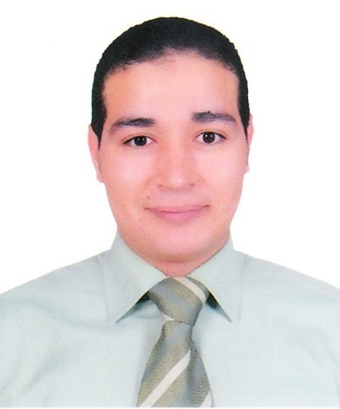
Place of Birth | AL Kanater Al Khairya. Al Qalubia
Nationality | Egyptian
Address | 21 Al Makhbaz Al Aly Street, Qalyoub
Mobile | +2 0122 51 61 955  +2 0101 43 31 552
E-mail | byassin@fei.org.eg  byassin429@gmail.com
Marital Status | Married
Current Job | -Senior economist at Federation of Egyptian Industries “FEI” (Sep, 2014 to date).  -Assistant Lecturer at Economics Department, Faculty of Commerce, Benha University, Egypt (Feb, 2013 to date).

EDUCATION
- Cairo University, Egypt
- Ph.D. in Economics, Faculty of Economics and Political Science Expected August 2018. The thesis title is “Macroeconomic and Institutional determinants of FDI in Egypt: empirical Study”.
- Enrolled in Ph.D. program in Economics, at Faculty of Economics and Political Science, Cairo University.

- Benha University, Egypt
- M. A in Economics (Thesis Title: The FDI Role in Economic Development in Egypt - with reference to the Malaysian experience), Faculty of Commerce, Benha University, 2011).
- M.A Qualifying two-year Program, Faculty of Commerce, Benha University (2004 – 2006), with AGP= 86% (Very good with honor degree).
- B.A in Economics, with AGP= 88.3% (Very good with honor degree) Faculty of Commerce, Benha University, 2004.

AREAS OF INTEREST AND RESEARCH
Financial Economics “FDI”, Economic Development, International Trade, Industrial Development.

CAREER OBJECTIVES
Understand Core theory and issues of the academic study and practical application of Economic Development (especially in the industry field). Be able to understand and contribute to debates in this space.
- To be a part of growth oriented organization where I can utilize my potential abilities to add value to the organization with concomitant opportunities of self-learning and professional growth that enable me to have diversified experience combining academic and practical work.

PROFESSIONAL EXPERIENCE
12 years of academic experience (both teaching and research) as a teaching and research assistant at the Economics department of Benha Faculty of Commerce, Egypt.

- Teaching Experience
Position Assistant Lecturer
Period Feb. 2013 to date
Institution Faculty of Commerce, Benha University, Egypt and
Arab Academy for science, technology, and Maritime Transport, College of International Transport and Logistics, Cairo Campus, Egypt

- Giving Applications in the following courses:
- Principles of Economics
- Microeconomics
- Macroeconomics
- Money and Banking
- International Trade
- Economic Resources
- Economic Planning and Economic Development.

- PRESENTATIONS
Selected presentations during the graduate level presented at Faculty of Economics and Political Science, Cairo University and Faculty of Commerce, Benha University Respectively:

- "Employment: A review of General Theory of Employment, Interest, and Money" May 2013.
- "Al-Hisba in Al- Islam, Comparative study with CAPMAS" Jan., 2013
- "Education As A key for Economic Development in Malaysia" May 2013
- " The IMF Role in Economic Reform in Egypt" June 2013
- "ECO" may 2006
Selected Seminar Presentations
Seminars held under supervision of the Economics Department, Faculty of Commerce, Benha University, Egypt
- "The subsidy system in Egypt", March 2010.
- "ICT industry in Egypt", May 2009.
- "The Role of Energy Sector in Arab Countries", March 2009.
- "The Global Financial Crisis", Nov. 2008.

PRACTICAL EXPERIENCE
-Senior Economist at the Federation of Egyptian Industries “FEI” (Sep, 2014 to date).

-Selected studies, Reports, and Presentations:
- "Increasing Egyptian Industrial Exports in the light of some international Experiences: China-South Korea-Malaysia-Arabic Version"
- "Towards a strategy for increasing Economic Penetration of Egyptian Industrial Sector within the Nile Basin Countries".
- "Proposed Plan for increasing Industrial Exports to Africa- Arabic Version "
- "The Brazilian experience in Economic Development-Arabic Version"
- "Cooperation Protocol between FEI and the Brazilian Side- Arabic Version ".
- "Cooperation Protocol between FEI and the Confederation of Danish Industry- Arabic Version ".
- "Obstacles that undermine the growth of the Egyptian Industrial Sector- Arabic Version".
- "the most important features of international experiences in supporting SMEs- Arabic Version".
- "Renewable Energy in Egypt" in English.
- "Investment Incentives in the Czech Republic- Arabic Version".
- "Evaluating the performance of the industrial exports in Egypt- testing the correlation between the change in the value of the industrial exports and the change in exchange rate values, after the last floating decision"-Arabic Version.
- "Investment Risks in Egypt- Foreign Direct Investment determinants and its related risks"-Arabic Version.

SKILLS

- Quantitative Skills: Basics (E-Views)
- Computer Skills: Proficient user of Ms Office (Word, Excel, and PowerPoint)
- Communication and Presentation Skills: Excellent
- Language

Language | Reading | Speaking | Writing
Arabic  English | Excellent  V.good | Excellent  V.good | Excellent  V.good

REFEREES

PROF. ABLA M. ABDEL-LATIF
Professor of Economics,
American University in Cairo (AUC), and the Chairman
of Special Council of the Economic Development
Affiliated to the Presidency, Cairo, Egypt
Tel. +2 0122 211 311 3
Email: alatif@aucegypt.edu

Prof. HAFIZ M. SHALTOUT
Professor of Economics,
Economics Department, Benha University, Egypt
Tel. +2 0100 50 44 33 1
Email: hshaltout@hotmail.com

