Photo
Photo
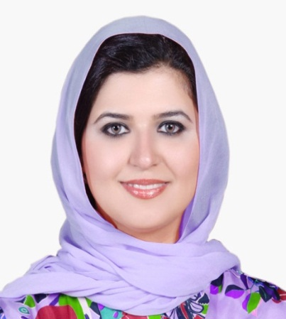
Curriculum Vitae (C.V.)

Personal Details
- Name: |  | Sahar A. AL-Hamli
- Address: |  | P.O. BOX 66033 Kuwait
- Telephone: |  | 00965-97101001
- E-mail: |  | sAlhamli@aou.edu.kw
- Job Title & Academic Rank: |  | Assistant Professor- Arab Open University- Kuwait Branch ,Head of Business Studies program
- Nationality & Date of Birth |  | Kuwaiti 19/05/1972
- Languages: |  | Arabic / English
Educational Qualifications
Degree | University |  | Specialization | Year
- PHD | Kings College of London - UK |  | Economic | 2013
- MSc | University of Westminster - UK |  | Economic | 2009
- BA | Kuwait University Kuwait |  | Economic | 1996
University Teaching & Work Experience History
July. 2016 – up to date:
- Head of the Business Studies Program Arab Open University (AOU) Kuwait Branch.
Feb. 2015- July 2016
- Assistant professor , Business studies program , Arab Open University (AOU) Kuwait Branch.
Teaching course money and Banking , Senesce of strategy B301A/B
Sep2014-2015
- Part Timer Teacher at PAAET- College of Business Studies
1.Principles of Management
- 2.Public Relations
Working experience :
Sept. 2004 –2015:
- Head of flowing Department Economic Affairs departments under Secretary Office ,Ministry of Finance
- Head of the Unit of Ministers Council's Affairs &Higher Councils, Minister Office - Ministry of Finance.
April 2000 - April 2004:
- Assistant Project Manager, Higher committee for Development & Economic Reform, Ministry of Finance.
Dec. 1996 – May 2000:
- Economic Researcher - Tax Dept. Studies & Research Unit.
Research and Publications
- Al Enezi,Sharma,Al-Hamli(2017) , Exploring Relationship in-between the Acquired Education and Current Job Scenario for the Employees in the Public Sector, State of Kuwait. The Journal of American Academy of Business, Cambridge, Vol. 23, No. 1, September 2017. The ISSN number is 1540 – 7780 which The Library of Congress, Washington DC, issues. (Acceptance letter)
- Al-Hamli, S. (2016).Islamic Bounds and their Role in Economic Development. Review of Economics & Politics Science Journal of University of Cairo University. The ISSN number is 2356-9980, Vol.1, No. 3 , July 2016 ,Pp:29-49.
- Al-Hamli, S.). Measurement & Evaluation of Kuwait Development plan. Aneveshika. Journal of Green Heaven Instate of Management and Research. The ISSN number is 2454-4280, Vol. 2. (2016-2017) Pp:84-95.
- Al-Hamli, S. (2014). The Concept and Application of Economic Reform: Arabic Case Studies. Journal of Ain Shams .vol.1.Pp:55-75.
- ALHamli, S. (2014).Islamic Bounds and their Role in Economic Development. AL-Nahda Journal of University of Cairo University. Vol. 4.Pp:85-104 .
- Al-Hamli,S.(2013). Administrative reform Concept Models and Mechanisms of countries. In Al Azhar Magazine .Vol. 10.Pp:332-362.

Research in Progress
- Starring Role of Education institution in nurturing entrepreneurship through Education Submitted to The Journal of The Business Review, Cambridge. Under process with first approval. 2017
- Extent of Success of the Economic Reform Program in Advancing Economic Development in Egypt and Kuwait. Journal of Ain shams University. 2016

Other Professional Experience

Professional Affiliations and Memberships
- Member of Kuwait Transparency Society.
- Head of Women Empowerment Center (Tamkeen) under Kuwait transparency society.
- Founder of " Seba "Women Club.
- Founder of Kuwait Development Economic Society.
- Member of the Kuwait Studies and Research institute.
- Member of Women Committee under Human Rights Committee of National Assembly of Kuwait.
- Member & Founder of Together Development Family Society
- Member of Thukhur leader Kuwaiti Group
Additional Information available on request
- References
- Credentials to support the claims made in this CV (e.g., Details of specific work experiences, certificates etc.)

