Rehab Mahmoud Hassan Abdel-Fattah
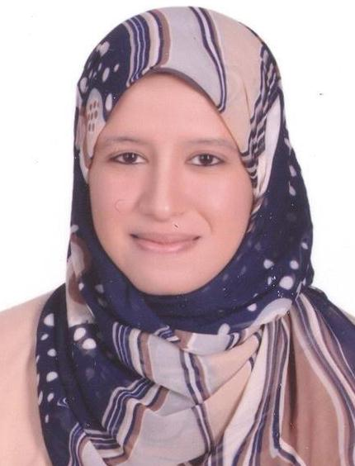
Borg Dr Soha-Mekky, Dr Tolba Eweda Street,
El Kawmia-Zagazig , Sharkia, Egypt.
Tel home: ( 055 )2362055 / Mob : ( 0106 )4236982
E-mail : RehabMahmoud2020@gmail.Com
Job objective:
Seeking a teaching assistant position in accounting department in a university or an academy that will utilize my education and training.
Education background:
September 2007-September 2011 | Bachelor degree in accounting, Faculty of commerce, English section Zagazig University.  With Grade: Excellent with first class honor.
September 2011–September 2013 | Pre –master in accounting, Faculty of commerce, Zagazig University.  With Grade: Very Good.
September 2013 – June 2016 | Finished master thesis entitled ( The Role Of Financial Reporting Quality In mitigating The Restrictive Effect Of Dividend Policy On Capital Investment Decisions – an empirical study in Egyptian environmental ) , Faculty of commerce , Zagazig University.

Work Experience:
December 2011 - present | Working as teaching assistant in Accounting Department, Faculty Of Commerce – English Section, Zagazig University.
Training & Extra courses:
July 2006 - august 2006 | Efficiently completed courses of ( General English – Computer Science ) in Green Future Academy , Zagazig , Sharkia .
July 2009 – august 2009 | Efficiently completed Banking Training , Miser Banque , Zagazig Branch , Zagazig , Sharkia.
Augest 2009 | Successfully completed Camp for Leadership Development Sponsored by the Ministry of Higher Education and Scientific Research Egyptian, arish city .
July 2009 – September 2009 | Efficiently completed course of General English – New Next Academy , Zagazig , Sharkia .
July 2010 – August 2010 | Efficiently completed course for ( Effectiveness Leader& Management ) – New Next Academy , Zagazig , Sharkia.
July 2010 – August 2010 | Efficiently completed Banking Training , National Bank Of Egypt , Abo-Kbeer Branch , Abo-Kbeer , Sharkia.
July 2011 - july 2012 | Successfully completed The Education Development Program for Egyptian universities (EDUEgypt) Sponsored by New Horizons For Training And Education which include these courses programs :  English Language Skills Program  Business Process Outsourcing(BPO) Skills Program  A variety of courses :  Voice and Accent  Language Practice  Customer Service Skills  Business Skills  Soft Skills  Aptitude Skills  Analytical Thinking skills  PC skills  Cultural Sensitivity  BPO Industry Orientation  Business Skills Program  it focuses on general business skills including English Language skills, Customer Service, Soft Skills and BPO orientation.  Information Technology Outsourcing (ITO) Skills Program

Voluntary work:
- March 2007 – present Collective work with my classmates in faculty
- Voluntary visit to children with cancer – Sidnaui hospital , Zagazig .
- Voluntary visit to Many orphanages , zagazig .
- Voluntary share in Organizing a ceremony on Orphan Day every year in Masria Plaza Garden , Zagazig .
- February 2007 – present Volunteer in the charities of Sonaa El – Haiah , Zagazig .
- Volunteer teacher in Science Power Project sponcered by Vodafone Charities .
- June 2007 – Present Volunteer in the charities of Resala , Zagazig .
- Participated in the establishment of The First Re-Manufacturing Department of Resala , Zagazig Branch .
Skills:
Personal skills : Team Worker, Quick Learner, Enjoy Challenge, Team Player & Fast Learner .
Computer skills : Very good computer and internet user.
Language skill :
- Fluent in both written and spoken Arabic.
- Very Good in both written and spoken English.

Work Experience:
Penglake company for internet services, Sales clerk & Customer service' agent .  - Guided customers to the appropriate department  - Assisted with the stocking and pricing of merchandise  - Answered incoming phone calls and directed to proper department  - Assists co-workers with various office tasks  - Marketing our services | 2011 -2012
Teaching Assistant in Accounting Department, Zagazig University – English Section, Sharkia .  Participating in teaching these courses :  - Principals of Cost Accounting.  - Principals Of tax Accounting.  - The Environmental Accounting and Auditing.  - Management accounting.  - Financial accounting. | 2012- present

Interests : Computer - Reading – Traveling .
Personal information:
- Date of Birth : 20 april 1990
- Marital Status : married with one baby.
- Nationality : Egyptian.

References available upon request.....

